**The Safety Dance - Men Without Hats**

[**http://play.riffstation.com/?v=AjPau5QYtYs**](http://play.riffstation.com/?v=AjPau5QYtYs)

Capo 3

B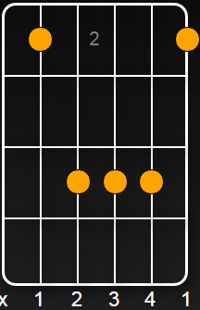F#/Gb 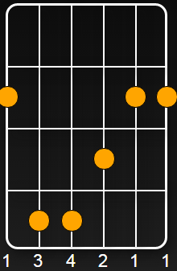

A

We can dance if we want to

G D

We can leave your friends behind

G

Cause your friends don't dance and if they don't dance

A E

Well they're no friends of mine

A

I say, we can go where we want to

G D

a place where they will never find

G

And we can act like we come from out of this world

A E

Leave the real one far behind

D G C F -2x-

And we can dance and sing

A

We can go when we want to

G D

The night is young and so am I

G

And we can dress real neat from our hats to our feet

A E

And surprise 'em with the victory cry

A

Say, we can act if want to

G D

If we don't nobody will

G

And you can act real rude and totally removed

A E

And I can act like an imbecile

**Chorus:**

**D G**

**I say, we can dance, we can dance**

**C F**

**Everything's out of control**

**D G**

**We can dance, we can dance**

**C F**

**We're doing it from pole to pole's**

**D G**

**We can dance, we can dance**

**C F**

**Everybody look at your hands**

**D G**

**We can dance, we can dance**

**C F**

**Everybody takin' the cha-G-G-ance**

**A E B Gb**

**It's safe to dance, Oh well it's safe to dance,**

**E B Gb**

**Yes it's safe to dance**

A

We can dance if we want to

G D

We've got all your life and mine

G

As long as we abuse it, never gonna lose it

A E

Everything'll work out right

A

I say, we can dance if we want to

G D

We can leave your friends behind

G

'Cause your friends don't dance and if they don't dance

A E

Well they're no friends of mine

**Chorus:**

Outro:

A E B Gb

Well it's safe to dance Well it's safe to dance

Yes it's safe to dance Well it's safe to dance

Well it's safe to dance It's a Safety Dance

Well it's a Safety Dance Oh it's a Safety Dance

Oh it's a Safety Dance Well it's a Safety Dance